**HAZARDOUS**

**AREA**

**MONITORING**

**FOR**

**INDUSTERIAL**

**PLANT**

**POWERED**

**BY**

**IoT**

Team

ID:

PNT2022TMID50270

Project

Development

Phase:

Sprint

3

**STEP 1 :**

Make a connection between the node functions in the node red

application.

**STEP**

**2**

**:**

To

view

the

Output

view

the

node

-

red

dashboard.

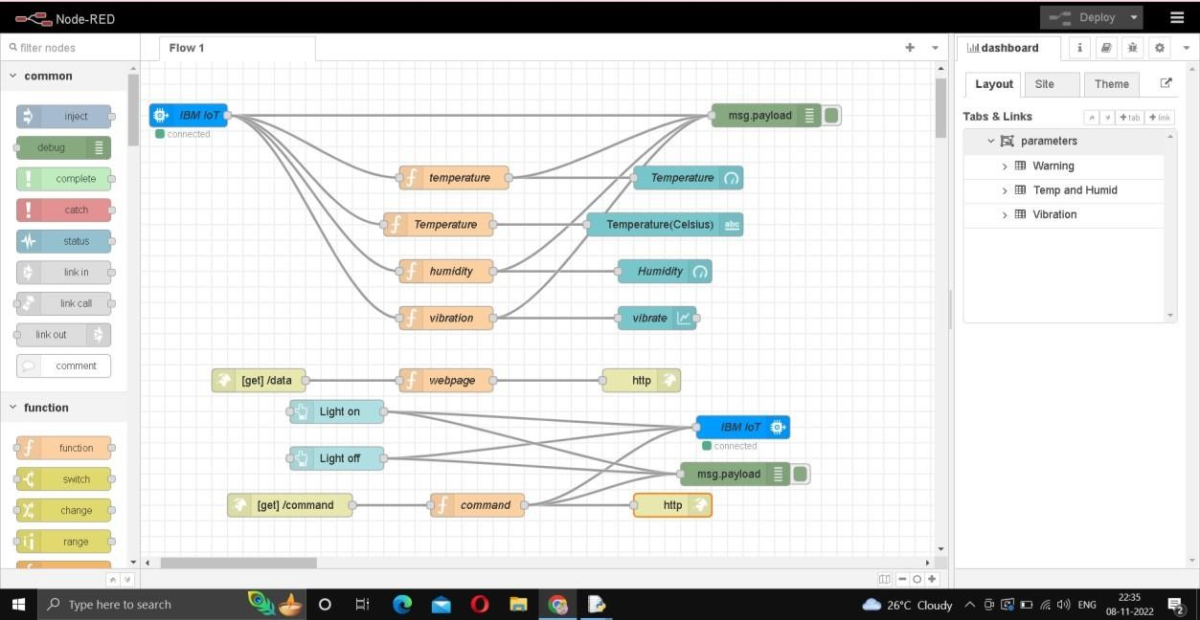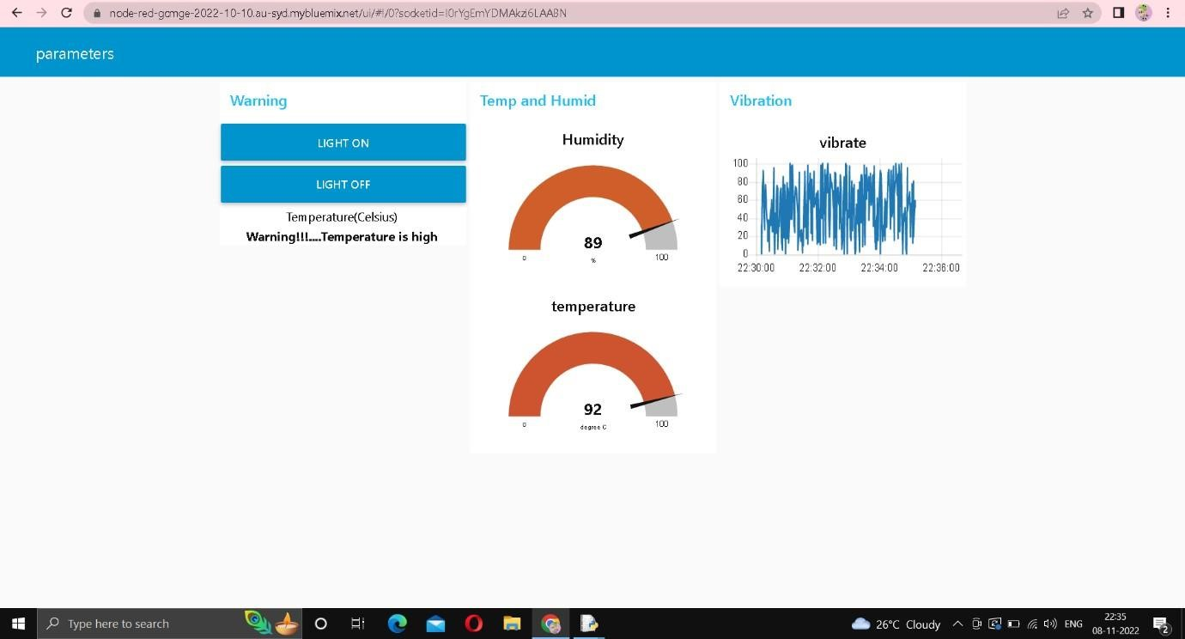

**STEP 3 :**

To view the web UI copy the link in the node red upto .net/ and type data and user can view

the

temperature

, humidity

and

vibration.

